

***FedEx Sales Transaction***

Analyze of FedEx Sales Data



**Author:**

* DJENEBA TRAORE

October 20, 2024

Contents

INTRODUCTION 2

OBJECTIVES 3

Sales Performance Analysis: 3

Customer Segmentation: 3

Trend Analysis: 3

Operational Efficiency: 3

Profitability Analysis: 3

DATA DESCRIPTION 4

METHODOLOGY: EXPLORATORY DATA ANALYSIS (EDA) 5

**A.** **TRENDS OVER TIME (MONTHLY/SEASONAL PATTERNS):** 5

**B.** **POPULAR PRODUCT CATEGORIES:** 6

**C.** **KEY CUSTOMER SEGMENTS:** 7

**D.** **POPULAR SHIPPING MODE:** 8

**E.** **SALES BY ADDRESS:** 9

RESULT / KEY INSIGHTS 10

CONCLUSION 11

# INTRODUCTION

This report provides an in-depth analysis of FedEx sales transactions to uncover insights into sales performance, customer segmentation, product trends, and operational efficiency. Through comprehensive data analysis, businesses can better understand which products are driving revenue, how customer segments are performing, and the impact of shipping costs on overall profitability.

The objective is to leverage sales data to inform key business decisions such as inventory management, marketing strategies, and operational improvements. By analyzing order trends, product preferences, and shipping methods, this report offers actionable insights to boost sales performance and optimize business operations.

The primary objectives of this analysis are as follows:

* Sales Performance Analysis: To understand the overall sales trends, identify top-selling products, and assess the effectiveness of marketing strategies.
* Customer Segmentation: To categorize customers into distinct segments based on their purchasing behavior, enabling targeted marketing and tailored offerings.
* Trend Analysis: To identify seasonal patterns, growth trends, and potential fluctuations in sales over time.
* Operational Efficiency: To evaluate the efficiency of order processing, shipping, and delivery operations, identifying areas for optimization.
* Profitability Analysis: To assess the profitability of different products, customer segments, and sales channels, informing pricing and cost management decisions.

By achieving these objectives, this analysis will provide actionable recommendations to enhance sales performance, improve customer satisfaction, and optimize operational efficiency for FedEx.

# OBJECTIVES

This comprehensive analysis aims to unravel the intricacies of FedEx's sales data, providing valuable insights into sales performance, customer behavior, operational efficiency, and overall profitability. By meticulously examining various data points, we seek to identify trends, patterns, and areas for improvement within the organization.

### Sales Performance Analysis:

By analyzing sales data, a business can understand which products are selling well and which are not. This can help in making decisions about inventory management, marketing strategies, and product development.

### Customer Segmentation:

The 'Customer Segment' column suggests that the business categorizes its customers into different segments. Analyzing this data can provide insights into the buying behaviors of different customer groups, which can inform targeted marketing and sales strategies.

### Trend Analysis:

By analyzing sales over time, a business can identify trends and seasonal patterns. This can inform forecasting and planning for future sales periods.

### Operational Efficiency:

Analysis of order dates, ship dates, and shipping costs can help a business identify inefficiencies in its operations. For example, if shipping costs are higher for certain types of orders or at certain times, the business might be able to adjust its processes to reduce costs.

### Profitability Analysis:

By comparing sales and shipping costs, a business can assess the profitability of different products, customer segments, or time periods. This can inform pricing and cost management strategies.

# DATA DESCRIPTION

To facilitate a comprehensive analysis of FedEx's sales data, we have utilized a dataset comprising the following key variables:

1. **Unique ID:** This is a unique identifier for each transaction or order. It can be used to track individual orders.
2. **Order Date:** This is the date when the order was placed. It can be used to analyze sales trends over time.
3. **Ship Date:** This is the date when the order was shipped. It can be used to calculate shipping time and efficiency.
4. **Shipping Cost:** This is the cost of shipping for each order. It can be used to analyze shipping costs and their impact on overall sales.
5. **Order Quantity:** This is the quantity of items in each order. It can be used to analyze the volume of sales.
6. **Sales:** This is the total sales from each order. It can be used to analyze revenue.
7. Customer Segment: This is the segment of the customer who placed the order. It can be used to analyze customer behavior and preferences.
8. **Order Priority:** This is the priority of the order. It can be used to analyze the urgency of orders.
9. **Product Category and Product Sub-Category:** These are the categories and sub-categories of the products in the order. They can be used to analyze product performance and customer preferences.
10. **Ship Mode:** This is the mode of shipping for the order. It can be used to analyze shipping methods and their efficiency.
11. **Province:** This is the province where the order was placed. It can be used to analyze geographical trends in sales.
12. **Product Container:** This is the type of container used for the product in the order. It can be used to analyze packaging preferences and efficiency.

This dataset provides a robust foundation for our analysis, allowing us to explore various aspects of FedEx's sales performance, customer behavior, and operational efficiency.

# METHODOLOGY: EXPLORATORY DATA ANALYSIS (EDA)

### **TRENDS OVER TIME (MONTHLY/SEASONAL PATTERNS):**

The provided dataset covers a full year from January 1, 2018, to December 31, 2018, offering a comprehensive view of sales trends throughout the year.

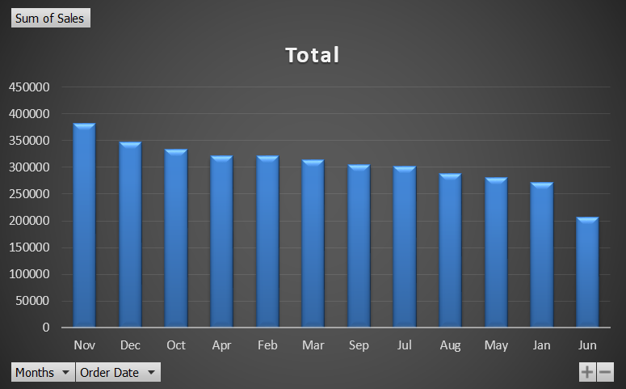

**Seasonal Patterns:** Analysis of monthly sales data reveals distinct seasonal patterns:

* **Peak Sales in November:** November emerged as the month with the highest sales, totalling 382,636.07. This peak in sales might be attributed to factors such as holiday shopping, year-end promotions, or other seasonal events.
* **Lowest Sales in June:** June recorded the lowest sales, reaching 206,787.37. This dip in sales could be due to factors like reduced consumer spending during summer months or specific industry-related events.

**Further Analysis:** To gain deeper insights into seasonal trends, consider the following:

* **Year-over-Year Comparisons:** Compare sales data from 2018 to previous years to identify long-term trends and potential anomalies.
* **Seasonal Factors:** Explore external factors that might influence seasonal sales patterns, such as holidays, weather conditions, or industry-specific events.
* **Promotional Activity:** Analyze the impact of promotional activities and marketing campaigns on seasonal sales fluctuations.

By examining these factors, we can develop a more nuanced understanding of the seasonal dynamics driving FedEx's sales performance.

### **POPULAR PRODUCT CATEGORIES:**

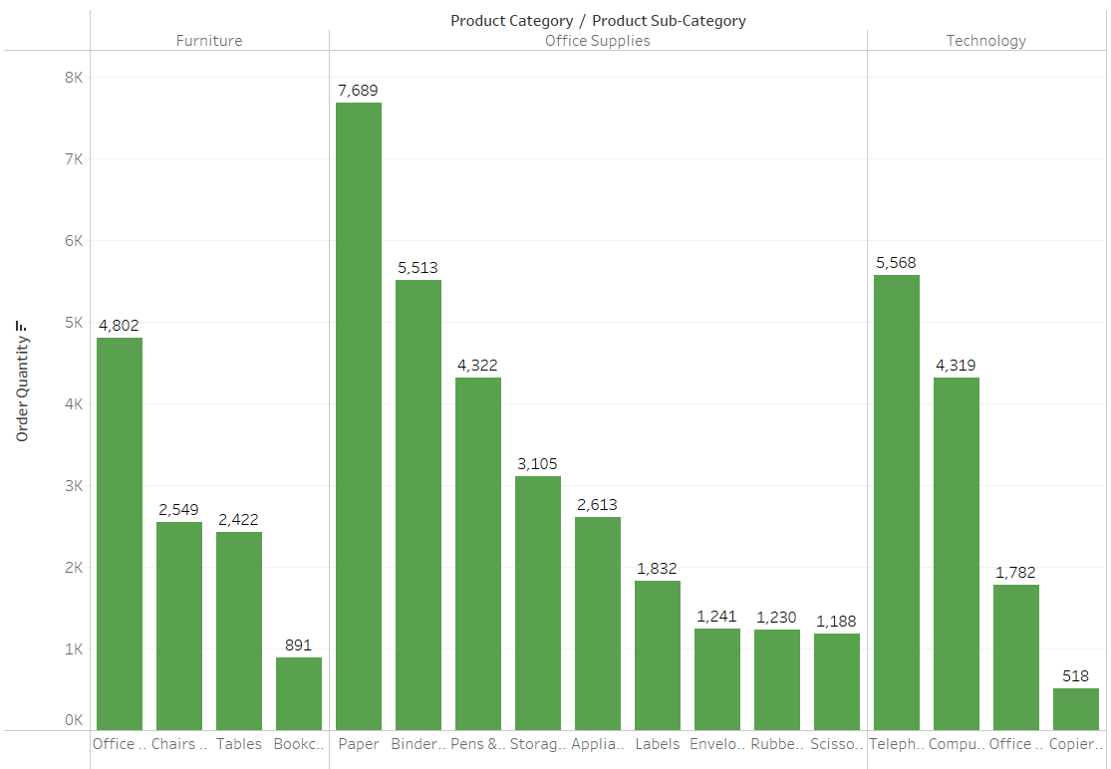

The most popular product category is:

**Office Supplies** with 28,733 orders, followed by **Technology** with 12,187 orders, and **Furniture** with 10,664 orders.

All divided in Sub-Category, following the order from the most popular to the less one:

1. Paper
2. Telephone and communication
3. Binders and Binder Accessories
4. Office Furnishings
5. Pens & Art Supplies
6. Computer Peripherals
7. Storage & Organization
8. Appliances
9. Chairs & Chairmats
10. Tables
11. Labels
12. Office Machines
13. Envelopes
14. Rubber Bands
15. Scissors, Rulers and Trimmers
16. Bookcases
17. Copiers and Fax

### **KEY CUSTOMER SEGMENTS:**

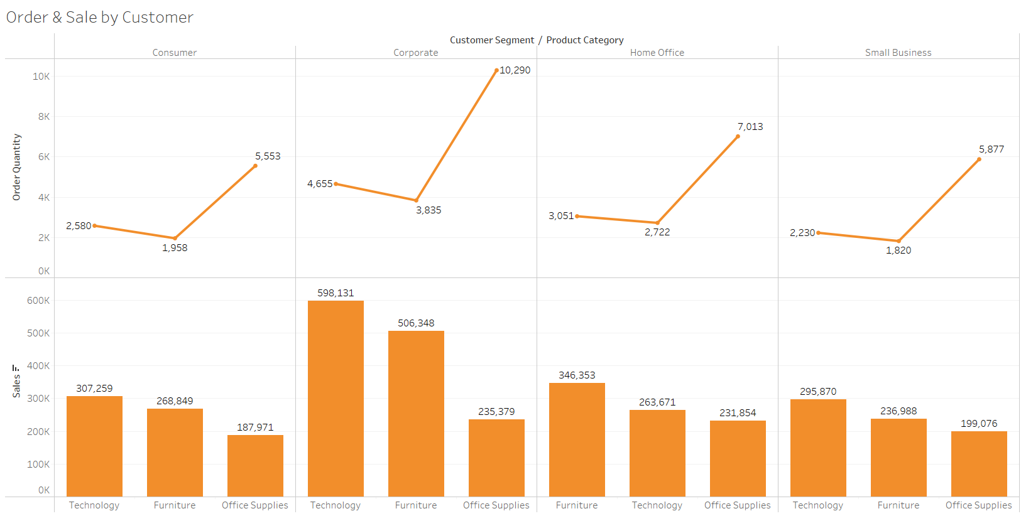

**Corporate Dominance:** The Corporate segment emerges as the most significant customer segment, accounting for 18,780 orders and a substantial sales profit of 1,339,858. This suggests that corporate clients play a pivotal role in FedEx's overall revenue generation.

**Home Office and Consumer Segments:** The Home Office and Consumer segments follow closely behind, demonstrating consistent demand for FedEx's services. Home Office customers contribute 12,786 orders and a sales profit of 841,878, while Consumer customers place 10,091 orders, generating a sales profit of 764,079.

**Small Business Potential:** The Small Business segment, although slightly smaller in terms of order volume (9,927 orders), still contributes significantly to sales, with a total profit of 731,934. This segment presents opportunities for further growth and targeted marketing efforts.

### **POPULAR SHIPPING MODE:**

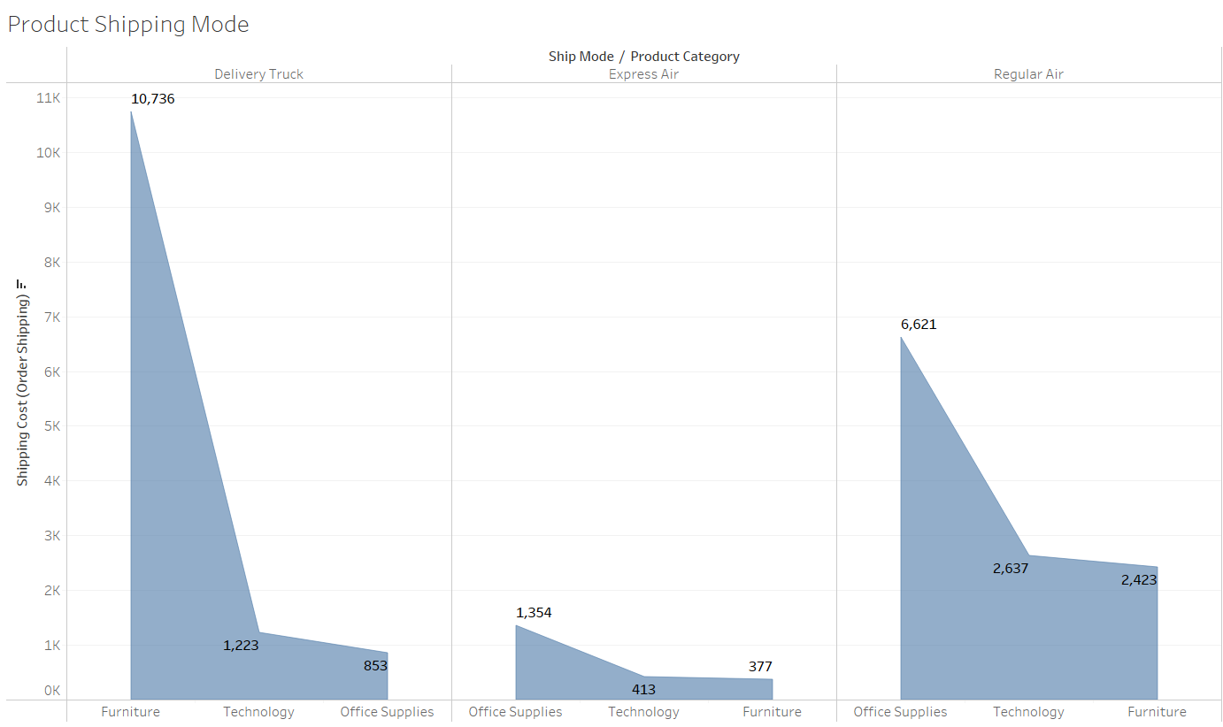

**Delivery Truck Dominance:** Delivery Truck emerges as the preferred shipping mode, accounting for 12,812 orders. This preference might be attributed to factors such as cost-effectiveness, reliability, or suitability for specific types of shipments.

**Regular Air as a Close Second:** Regular Air shipping mode is a close second, with 11,681 orders. This mode likely offers a balance between speed and cost, making it suitable for various shipping needs.

**Express Air for Urgent Shipments:** Express Air shipping, while the least used with 2,144 orders, is likely preferred for urgent shipments requiring expedited delivery.

Shipping Mode Optimization: To optimize shipping operations and customer satisfaction, consider the following:

* Cost-Benefit Analysis: Evaluate the cost-benefit ratio of each shipping mode to identify the most suitable options for different types of shipments and customer segments.
* Delivery Time Analysis: Analyze delivery times for each shipping mode to assess their performance in terms of speed and reliability.
* Customer Satisfaction: Gather customer feedback on shipping mode preferences and performance to identify areas for improvement.
* Mode-Specific Strategies: Develop strategies tailored to each shipping mode, such as optimizing routes for Delivery Truck, negotiating rates with air carriers, and ensuring efficient handling of Express Air shipments.

By optimizing shipping modes and strategies, FedEx can enhance customer satisfaction, improve operational efficiency, and potentially reduce shipping costs.

### **SALES BY ADDRESS:**

Regional Sales Analysis reveals significant variations in sales performance across different provinces and cities.

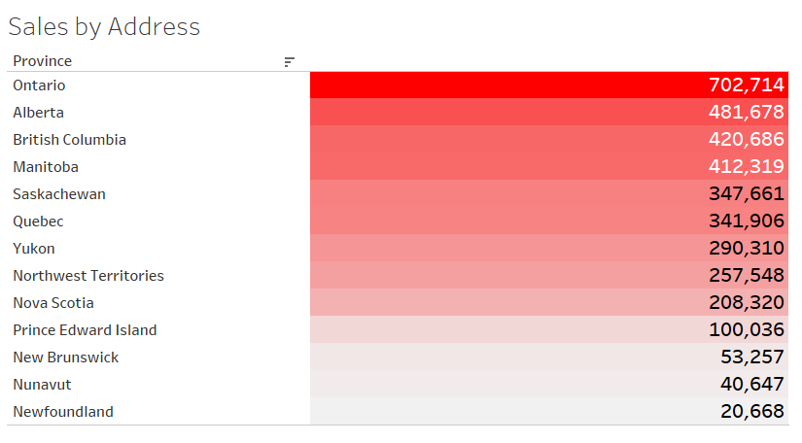

**Ontario City Dominance:** Ontario City emerges as the top-performing region, generating the highest sales profit of 702,714. This suggests that Ontario City represents a high-potential market for FedEx, warranting further exploration and investment.

**Underperforming Regions:** Several provinces, including New Brunswick, Nunavut, and Newfoundland, exhibit very low sales profits, indicating opportunities for growth and improvement. These regions may require targeted marketing efforts, enhanced service offerings, or increased market penetration to boost sales.

Regional Market Analysis: To gain a deeper understanding of regional sales variations, consider the following:

* Market Size and Demographics: Analyze the population, economic activity, and consumer behavior in each region to identify factors influencing sales performance.
* Competitive Landscape: Assess the competitive landscape in each region to identify potential barriers to entry and opportunities for differentiation.
* Infrastructure and Logistics: Evaluate the infrastructure and logistics capabilities in each region, such as transportation networks and warehousing facilities, to ensure efficient operations.
* Customer Preferences: Explore regional preferences for products, services, and shipping methods to tailor offerings to specific market needs.

By conducting a thorough regional market analysis, FedEx can identify growth opportunities, optimize resource allocation, and develop targeted strategies to enhance sales performance in underperforming regions.

# RESULT / KEY INSIGHTS

**Customer Segmentation:**

Corporate Dominance: The 'Corporate' customer segment emerges as the primary driver of sales, accounting for a significant portion of FedEx's revenue. This highlights the importance of maintaining strong relationships with corporate clients and tailoring offerings to meet their specific needs.

**Shipping Mode:**

Cost-Conscious Choice: Express Air, despite being the cheapest shipping mode, might not be the most popular choice due to potential trade-offs in terms of delivery speed or reliability. FedEx could explore strategies to enhance the appeal of Express Air, such as offering additional benefits or incentives.

**Order Priority:**

High Priority Focus: 'High' order priority is the most frequently selected, indicating a significant demand for expedited services. FedEx should ensure efficient handling of high-priority orders to meet customer expectations and maintain customer satisfaction.

**Product Category:**

Office Supplies Lead the Way: The 'Office Supplies' category dominates sales, accounting for 56% of the total. This suggests that office supplies are a core product line for FedEx, and efforts to strengthen this category, such as expanding product offerings or improving supply chain efficiency, could further enhance sales performance.

**Regional Sales:**

Ontario and Alberta as Top Regions: Ontario and Alberta emerge as the top-performing regions, indicating strong market penetration and demand in these areas.

Growth Potential in British Columbia and Manitoba: While British Columbia and Manitoba currently have lower sales, their potential for growth should be closely monitored. FedEx could explore strategies to expand its market share in these regions, such as targeted marketing campaigns or partnerships with local businesses.

**Product Performance:**

Table and Rubber Band Extremes: The 'Table' product stands out as the top-seller, while the 'Rubber Band' product exhibits the lowest sales. Analyzing the reasons behind these disparities can provide insights into product demand, pricing strategies, and inventory management.

# CONCLUSION

This comprehensive analysis of FedEx's sales data has provided valuable insights into the company's performance, customer behavior, operational efficiency, and profitability. Key findings include:

* **Customer Segmentation:** The 'Corporate' segment emerges as the most significant contributor to sales, highlighting the importance of maintaining strong relationships with corporate clients.
* **Shipping Modes:** Delivery Truck is the preferred shipping mode, while Express Air, despite being the cheapest option, might not be the most popular due to potential trade-offs in terms of speed and reliability.
* **Order Priority:** 'High' order priority is the most frequently selected, emphasizing the need for efficient handling of urgent orders.
* **Product Performance:** The 'Office Supplies' category dominates sales, indicating its significance as a core product line.
* **Regional Sales:** Ontario and Alberta are the top-performing regions, while British Columbia and Manitoba present opportunities for growth.

Based on these findings, FedEx can implement several strategies to enhance its performance:

* **Customer Focus:** Continue to prioritize and nurture relationships with corporate clients, while also exploring opportunities to expand market share in other segments.
* **Shipping Mode Optimization:** Evaluate the cost-benefit ratio of different shipping modes to identify the most suitable options for various customer segments and shipment types.
* **Order Fulfillment Efficiency:** Implement processes to ensure efficient handling of high-priority orders and minimize order fulfillment times.
* **Product Portfolio Management:** Analyze product performance to identify opportunities for product expansion, improvement, or discontinuation.
* **Regional Growth Strategies:** Develop targeted strategies to expand market share in underperforming regions, such as British Columbia and Manitoba.

By implementing these strategies, FedEx can strengthen its competitive position, improve customer satisfaction, and drive sustainable growth.